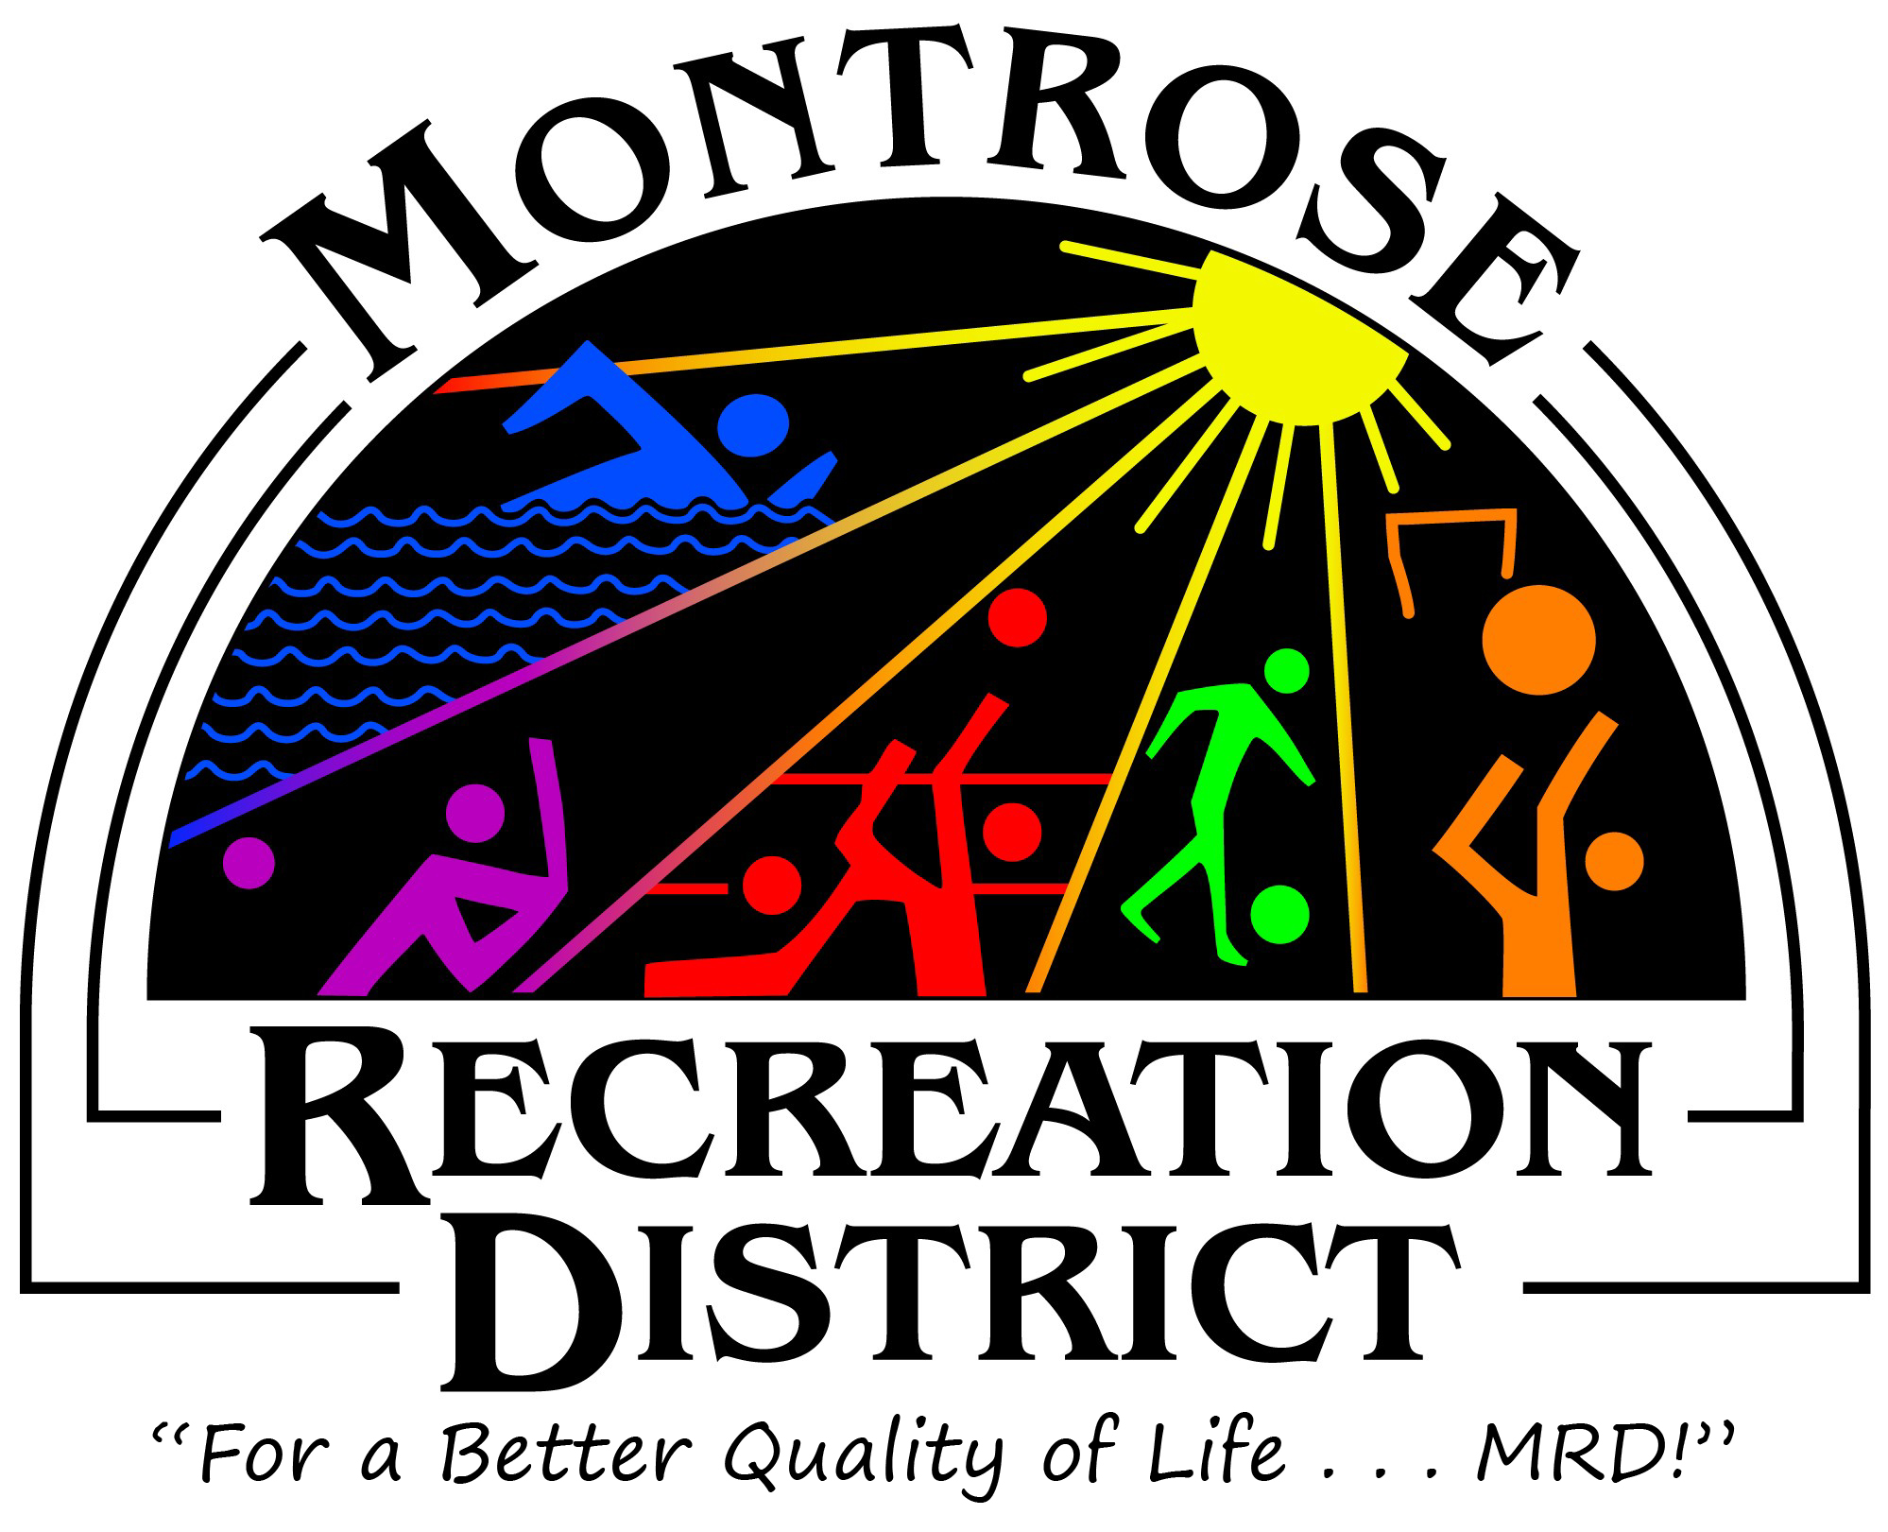

Agenda

PROS Consulting Presentation of the MRD Master Plan
June 15, 2020
2pm-4pm
Montrose Pavilion, 1800 East Pavilion Place, as well as MRD Park and Recreation Facilities

- 2:00pm-4:00pm - PROS Consulting Presentation of final MRD Master Plan
  - 2:00-2:10pm Introductions
  - 2:10-2:35pm Plan Process and Key Findings
  - 2:35-3:00pm Next Steps
  - 3:00-4:00pm Discussion and Q&A

- 4:00pm-6:00pm Site Tour
  - MRD and MRF Board will take a tour of MRD Parks and Facilities and will look through the lens of the Master Plan. What are our needs and improvements that need to be made.

