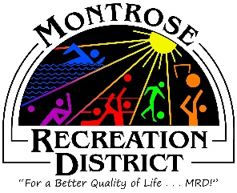

Master Plan Meeting

Growth Committee
Wednesday, May 7, 2021 at 1:00pm
Montrose Community Recreation Center
16350 Woodgate Road
Montrose CO 81401

Attendees:

- Status/Update;
  - Progress report of outstanding items
  - Monthly formal report to elected officials

- Focus Groups;
  - Update on attendees, roles and assignments
  - Logistics overview
- Virtual Public Meetings
  - Run through presentation finalize questions
    - Discuss; MRD or City mentioned on slides
  - Logistics overview
  - Marketing – get the word out!
- Public Engagement
  - Outcomes from virtual Public Meetings
  - Future engagement;
    - Website; Makemymontrose.com to watch presentation
    - Online survey – more comprehensive
    - HAPPiFEET
    - Intercept surveys

Next Meetings
Proposed, Thursday May 27 at 2pm
Thursday, June 17 at 2pm
Thursday, July 15 at 2pm
Montrose Community Recreation Center
16350 Woodgate Road
Montrose CO 81401

